A Cooking Lesson

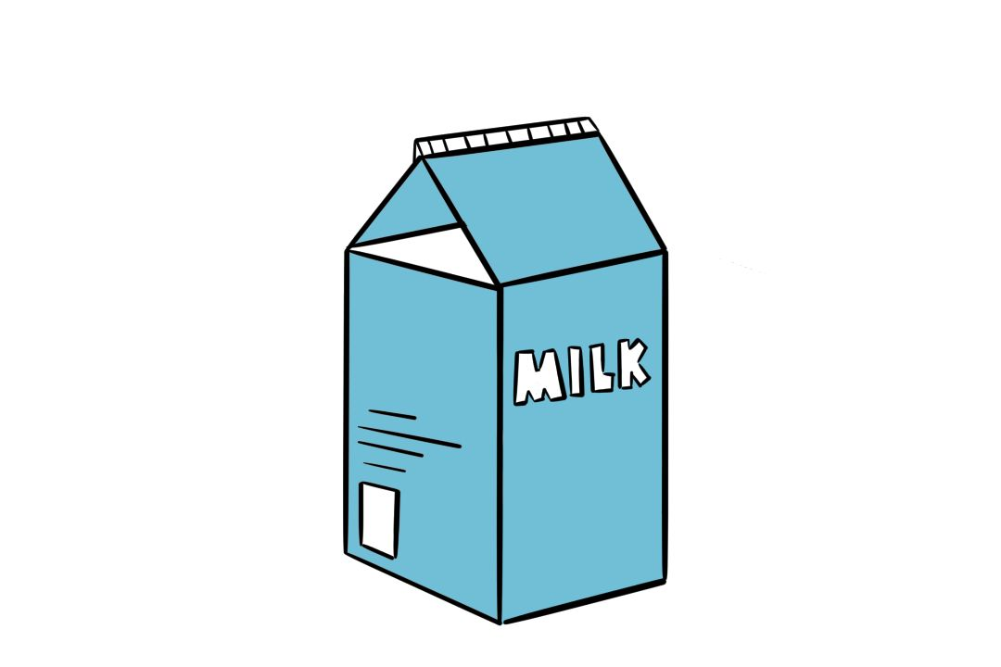

Name: ___________________

Year: ____________________

**Correct the spelling mistakes.**

Mr Smith will be taking the cooking class today; Mr and Mrs Smith are both talented chefs and own their own chain of estraurnats. The students of Class 7A will be learning the different types of 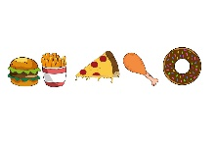and how they go with many of the other foods to make good tasting 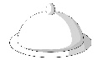es.

“Carbohydrates are fibres and starches that are found in icre, aedrb and tsaap. These are very important in a healthy diet but too much of it can be a little unhealthy,” Mr Smith explains. There are quite a few categories that various foods are grouped under, such as: 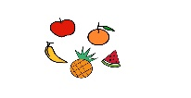 and 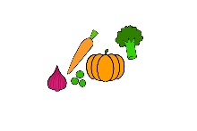, 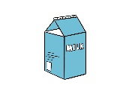 and protein. Mr Smith explains and gives the students examples of each category: and are a variety of oesnamg, selpap, gusarapsa, nalptgeg and storarc.  consists of seeehc, limk, urtgoyh, retutb, and cie rcame. Proteins are meats like hiccnek, fish/hisf, and malb. They can also be found in .

Everyone seems to be extremely interested in the lesson today because they are all taking notes and  the food categories with their peers. “Food is an important part of our days, children. We need to eat a lot, in order to grow, but we have to eat the , healthy foods. Too much of 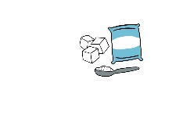 can really be bad for your health, it could make you diabetic. We still would love to be eating a small bit of  when we are much older, right?”, Mr Smith asks the kids, in a polite manner.

The students agree with Mr Smith and listen to his lesson for the rest of the afternoon about how many of these can be cooked together to make delicious and much healthier dishes for breakfast, lunch, and supper. He explains how tasty  can be, especially how different  can be eaten as snacks, how they contain natural  that are good for you and how you can make some fruit 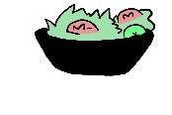 out of many fruits. The lessons ends and everyone is absolutely starving!